The 2026 New Year's Detox Protocol
Daryl C. Rich, D.C., C.S.C.S.
[Core] Chiropractic and Wellness Center
CoreRoanoke.com
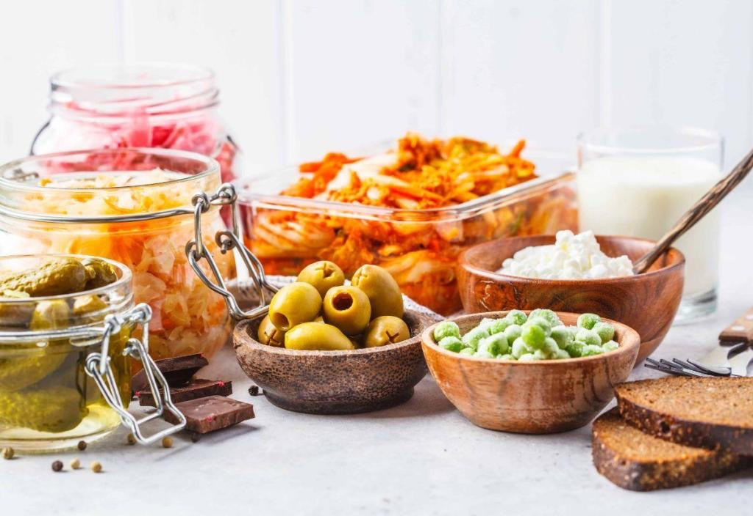
Happy New Year! As we step into 2026, it’s the perfect time for a fresh start. Our annual [LivFit] Detox Newsletter brings you an exciting, holistic protocol inspired by our popular Nutrition Seminar. This gentle 7-10 day plan combines intermittent fasting, nutrient-packed eating, and smart toxin reduction to help you feel energized, balanced, and renewed.

Imagine waking up with more vitality, clearer skin, steady energy, and a lighter, happier you. That’s the power of supporting your body’s natural detox pathways!

Why Detox? A Simple Breakdown
Your body is amazing at detoxing naturally through the liver, kidneys, gut, skin, and lymphatics. But everyday exposures—like pesticides, heavy metals, and plastics—can add up. A clean, whole-food focus helps lighten the load. Put aside the sugary processed foods of the typical American diet in favor of whole natural foods prepared at home.

Boost Gut Health: Holidays can disrupt your microbiome. This can easily lead to a leaky gut that has the potential to drastically decrease your health as it allows toxins to enter circulation into the blood stream and be spread throughout the body. Swap gluten-heavy treats for fermented foods (think sauerkraut or kimchi) and fiber-rich veggies to nurture good bacteria and heal your gut.

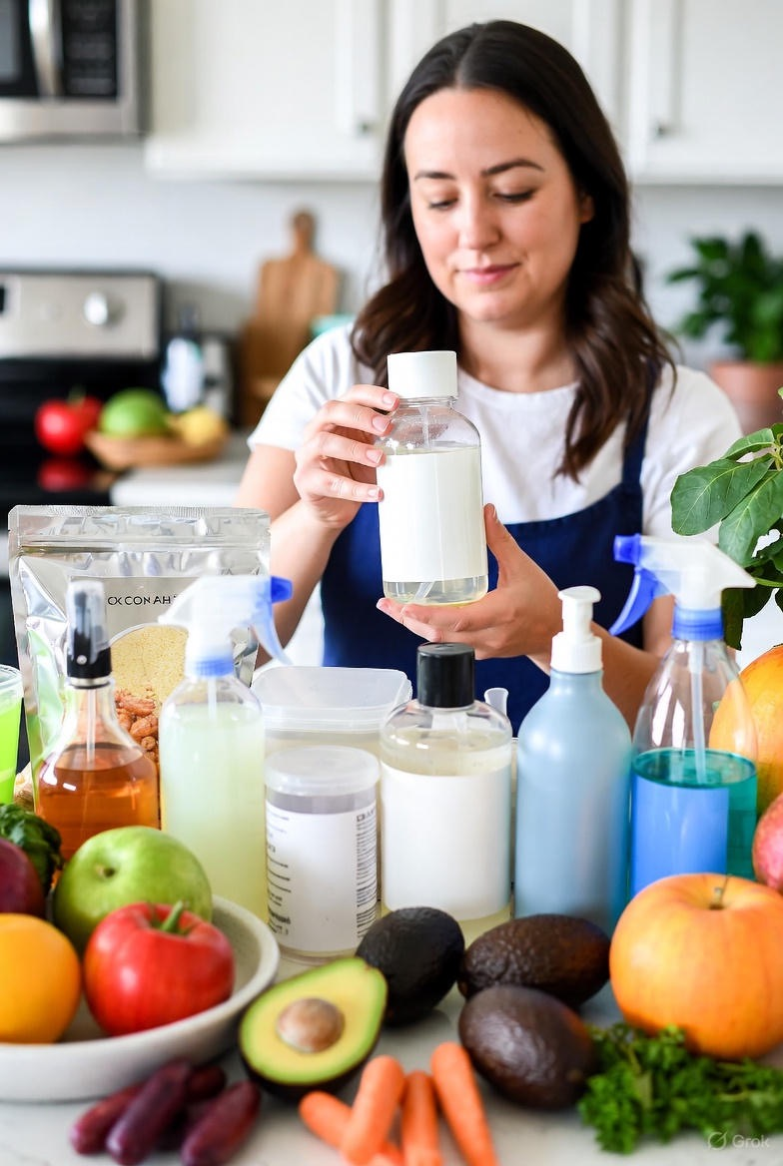
Potential Perks: Many people notice weight loss, less bloating, sharper focus, better mood, reduced inflammation—and a stronger foundation for long-term wellness.

Easy 4-Step Protocol to Get Started
Step 1: Prep Your Space (Days 1-2)
Clear out toxins at home! Switch to natural cleaners (vinegar works wonders) and paraben-free products. Stock organic produce—prioritize the EWG’s 2025 Clean Fifteen (like avocados, still low in pesticides) and go organic for Dirty Dozen items (new additions include potatoes and blackberries). Drink at least 64 oz of water daily, jazzed up with lemon.

Step 2: Fast & Feast Cleanly (Days 3-7)
Try a gentle 17-hour fast (eat noon to 7pm). This gives your body time to burn fat and recharge cells. Break your fast with healthy fats like avocado or nuts.

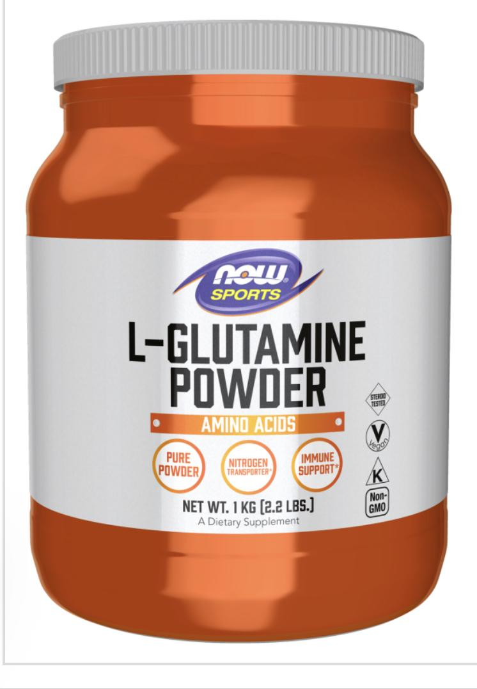
In your eating window: Load up on leafy greens, berries, grass-fed meats, and gut-loving ferments. Add prebiotics (sweet potatoes) and probiotics (yogurt) to sustain the healthy microbial balance being established in your gut.

Step 3: Supercharge Your Detox
Support your liver with milk thistle or NAC to aid in its ability to detox the body. Use L-glutamine if you're struggling with sugar cravings and to heal the gaps in the intestinal lumen for those suffering with a leaky gut.
Don’t forget to unwind with meditation or deep breaths—lower stress means better results!

Step 4: Go Deeper (If You’re Feeling Great)
Extend your detox a few days and try a 24-36 hour fast. Listen to your body—if headaches hit, ease up. Reintroduce foods slowly with bone broth to avoid digestive upset after a long fast. Wait an hour after breaking a fast before full meals.

Delicious Recipes to Keep It Fun & Tasty
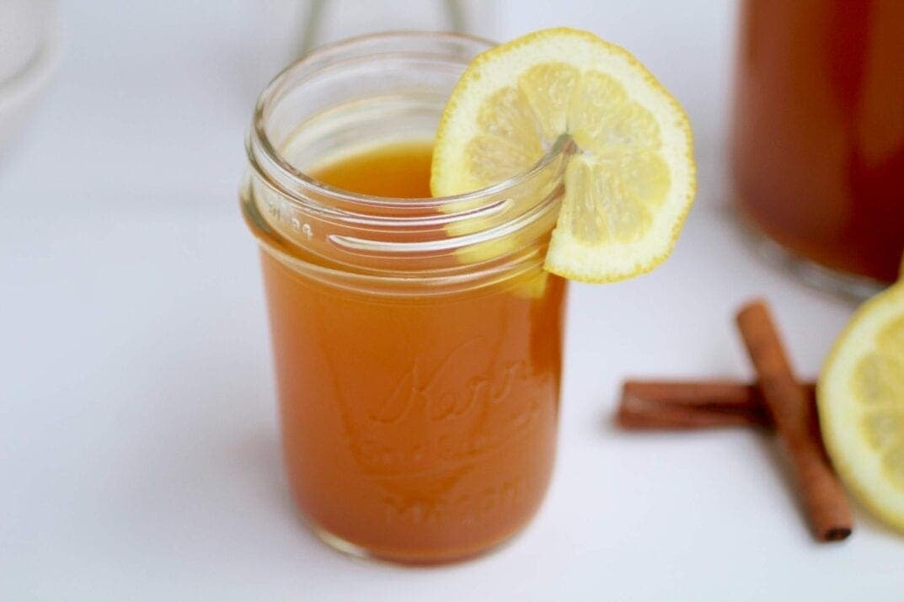
Sunrise Fat Burner Drink (Metabolism booster!)
Ingredients: 3 oz warm water, 1 tbsp lemon juice, 1 inch grated ginger, pinch of turmeric, cayenne, and cinnamon; optional 1 tsp honey for beginners.

- Instructions: Mix and drink upon waking. This boosts metabolism and detoxifies, Serves 1.

Green Power Smoothie (Antioxidant-packed start)
Ingredients: 1.5 cups spinach, 1 cup berries, ½ banana, 1 tbsp Greek yogurt, ½ tbsp chia seeds, ½ scoop whey protein, ½ cup water.

- Instructions: Blend until smooth; consume 30-45 minutes after waking or as a fast-breaker. Provides antioxidants for detox and hormonal support, Serves 1.

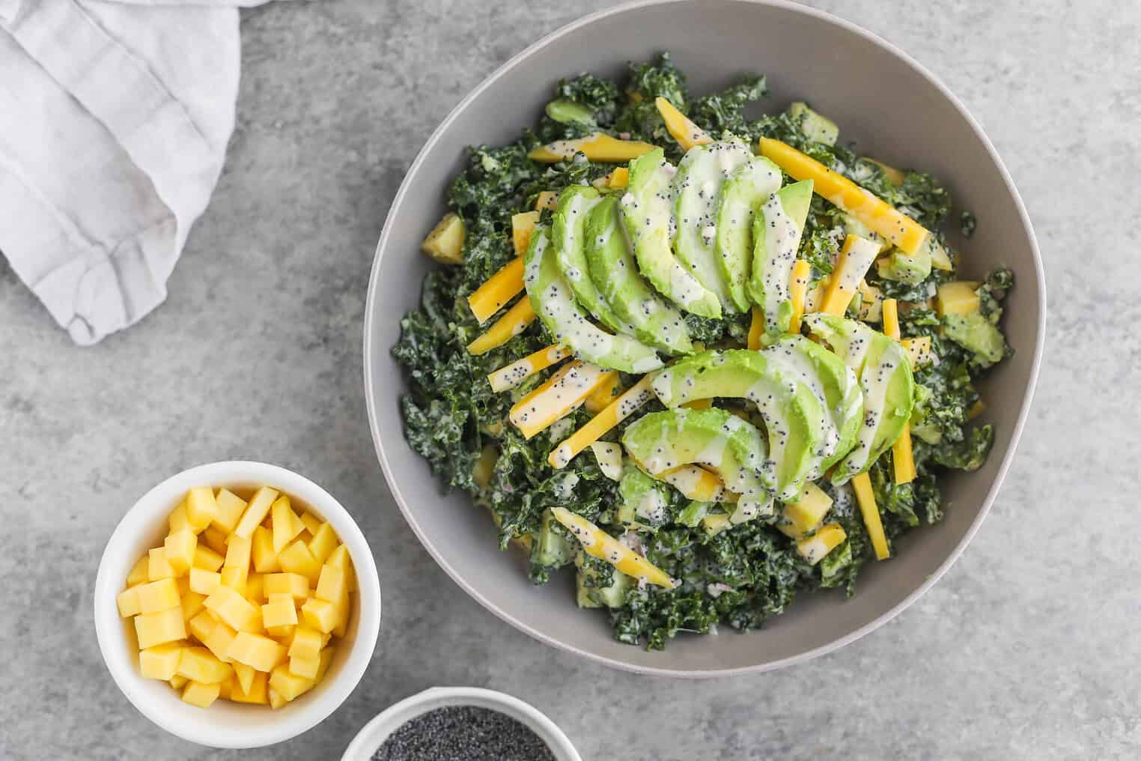
Tropical Salad (Fresh & vibrant)
Ingredients: 1 cup kale/arugula,
¼ mango,
½ cup garbanzo beans,
veggies (celery, radishes, onion, cucumber),
1 hard-boiled egg,
½ avocado,
¼ cup lentils/raisins.
Dressing: ¼ cup balsamic vinegar, 2 tbsp olive oil, mustard, garlic salt.

- Instructions: Chop and toss; dress lightly. Add fermented veggies like kimchi for gut health, Serves 1.
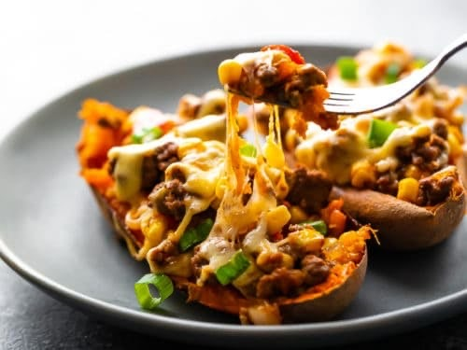
Sweet Potato Beef Taco (Hearty & satisfying)
Ingredients: 1 sweet potato (baked),
½ cup ground beef, bell pepper, onion, garlic, spices (cumin, chili, turmeric), greens.

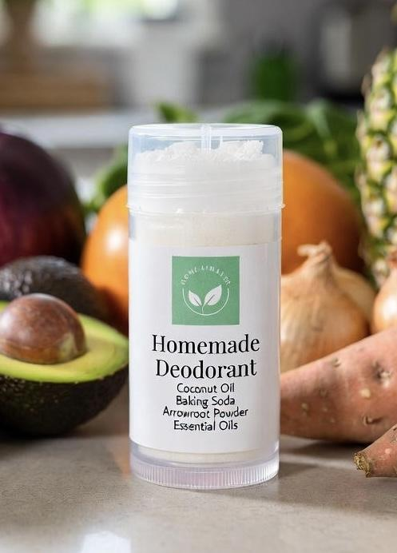
- Instructions: Sauté veggies and beef; stuff into halved potato. Nutrient-dense for liver support, Serves 1.

Bonus: Homemade Deodorant
Ingredients: Coconut oil, baking soda, arrowroot powder, essential oils.

- Instructions: Mix equal parts oil, soda, and powder; add oils for scent. Apply as needed to avoid aluminum exposure. Yields multiple uses.

Your Path to Lasting Wellness
Backed by 21 years of clinical insight, this detox protocol is practical and sustainable. Track how you feel, adjust as needed, and celebrate every win!
Detox isn’t just for January—it’s a lifestyle. Ready for more on gut healing, hormone balance, fasting, and beyond? Join our [LivFit] Seminar on February 19th & 26th—bring a friend!
Here’s to a vibrant, healthy 2026! Let’s make it your best year ever.

